Project Diary: 2020
A Record of My Time during the COVID-19 Shutdown

This is an historic event for NZ and globally – you will remember this!

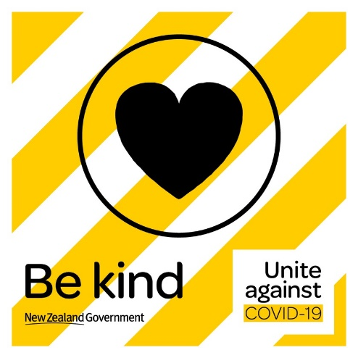
What would you like to look back on in the years to come, when you’re 20, 30, 50 or 70?
What would Anne Frank think if she were alive today at over ninety years of age and able to read her diary?
Diary
Think of a form you would like to work on to record your experience over the coming weeks. You could write, draw, paint, and work by hand, computer, digital art, build with hammer and nails or a combination of forms.
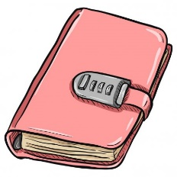
You could also team up and work on this with other members of your family, or perhaps other people in your home may like to do this for themselves as a project.

Here are a few ideas. Feel free to adapt these, combine these, or come up with your own:
1. Write a daily Diary Entry, outlining your activities, thoughts, and feelings.
2. Write a daily Diary Entry / Poem based around an object of the day, e.g. the changing colours of the tree in the garden, the tin of baked beans you have for lunch, your favourite black ink pen that runs out or ink.
3. Create a Visual Diary for the days/weeks ahead, where each day you choose an object (you could take a photo of this object, or sketch it, or ‘collect’ an object from your home like an old toy from childhood, etc.). Beside the object / photo of object write a few words or write a poem, or whatever you like, which tells something about this object and your relationship with it – what you are thinking/feeling about on this day.
4. Create a Visual Diary as a Digital Slide Show.
5. Write a series of poems or songs based on your experiences / thoughts / feelings of this time in isolation and/or the COVID-19 health emergency the world is facing.
6. Write a series of poems or songs based on what you see as the positive things coming out of this world crisis.
7. Keep a Gratitude Journal, where each day you chronicle THREE things you are grateful for. You could combine keeping a Gratitude Journal with a Visual Diary.
8. Write a series of handwritten letters to your Future Self. Hey! Remember me? It’s you. It can be easier to understand what matters to you or gain clarity on your thoughts and feelings when you have a tighter structure to work in, rather than a journal, which can be where we may off-load everything and anything. In a letter, we tend to write for that moment we’re in, getting things down on paper we need to sort through. Try writing your letters as if your near-future self is another person, someone who hasn’t seen what you are seeing and hasn’t experienced what you are currently going through. Instead of writing for your far-off future self, write for the self you’ll become in just a couple of months or a year – show that person the world you’re living in at the moment you’re writing from.
9. Create a painting or a series of paintings in response to your thoughts and/or feelings to this event.
10. Build or Design something (what ideas do you have?) in response to your thoughts and/or feelings to this event. It could be something that is practically useful or purely aesthetic.
11. Compose a piece of music that expresses your feelings/ideas of this time.
12. Create a series of collages / images / photographs / sketches (one per week) that records/expresses your experiences.

“Writing in a diary is a really strange experience for someone like me. Not only because I’ve never written anything before, but also because it seems to me that later on neither I nor anyone else will be interested in the musings of a thirteen-year old school girl. Oh well, it doesn’t matter. I feel like writing.” The Diary of Anne Frank

Actions
So now you have a plan in place to show how you might record your time in shutdown. However, what is it going to be like being at home for four or more weeks? How are you going to spend your time? While it will be nice to hear your thoughts and feelings, it would also be nice to hear what you have actually done or achieved.
- Think of the things that you enjoy doing – make a list of things you know you will probably do for fun and leisure. In many ways, these are the ‘easy things’ or the things that you would do anyway. Naturally these will be part of your diary.
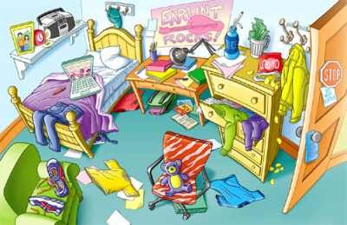

- Now think of the things you could do around your home that would help others but also allow you to learn and feel good about how you used this time – we could see these as ‘challenging things’ or things that might take thought and effort. Explore some ideas by yourself but also with your family, make a list or get someone to help you make a list.

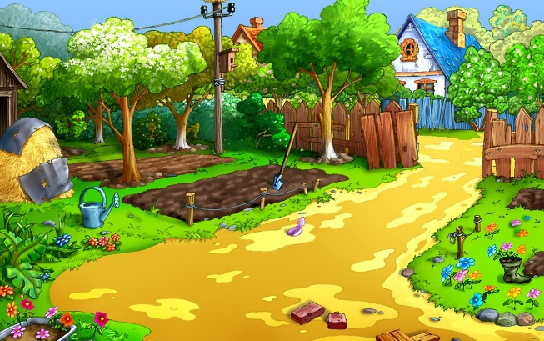

As part of keeping your diary – we are going to ask you to include some actions that show you have gone beyond ‘easy things’ and attempted ‘challenging things’.
You should talk with the people in your home to help you plan these… but here is an idea to get you started.
Every week you could look to complete 5 small jobs/projects that include:
- Help caregivers with a job/project that involves food (making bread or dinner from a recipe).
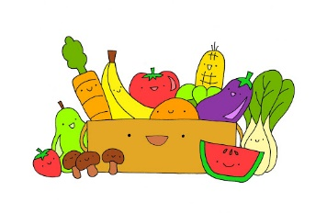
- Help caregivers with a job/project that involves metal (washing car, cleaning the inside of the oven, helping fix a fence).
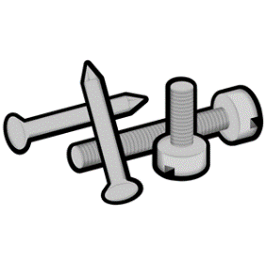
- Help caregivers with a project/job that involves wood (painting a shed, sanding weatherboards, stacking winter firewood)
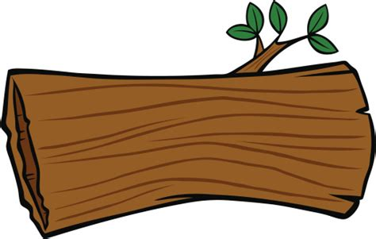
- Help caregivers with a project that involves soil (starting a winter garden, weeding, re-potting house plants)
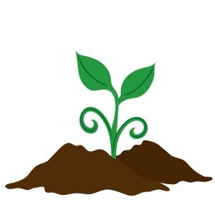

- Help out with entertaining younger siblings or pets (making a den or an obstacle course, walking the dog or cleaning out the chicken run).

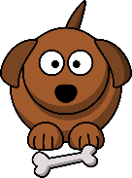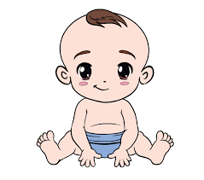

Remember your diary might not be written but drawn, spoken in a video or a series of pieces of art. But the idea is the same. How will you express how you are feeling and thinking? Can you complete tasks and projects and record your learning? How will you reflect on your feelings and actions?
Assessment
You will be assessed on this in an holistic way. I simply want you to share some or all of your experiences with your peers when you return to school. It would be great to have a presentation day so we can all catch up and share our experiences over this unique time.

You will always remember this event – it will prove invaluable to have some sort of record.

